**Assessing demand-side solutions for mitigating climate change**

Felix Creutzig, Joyashree Roy, Arnulf Grübler, Diana Ürge-Vorsatz, Jan C. Minx, Narasimha Rao, Elke Weber, Edgar Hertwich, William F. Lamb, Julia Steinberger, Frank Geels, Anjali Ramakrishnan, Ines Azevedo, Radhika Khosla, Wandi Bruine de Bruin, Oreane Edelenbosch, Massimo Tavoni, Gong Sun, Linus Mattauch, Cameron Hepburn, Holger Dalkmann

*[author order pretty random and to be updated according to contributions]*

**Research on climate change mitigation solutions often focuses on the role of technologies. An encompassing and integrated understanding of demand-side solutions, including those related to every-day life, is missing. Here we call for transdisciplinary advances on assessing demand-side climate solutions, investigating mitigation potentials, policy measures, and welfare implications.**

The IPCC’s next assessment report will feature a chapter on demand, services and social aspects of mitigation (Chapter 5 in the Working Group III of the AR6). This is a major innovation in the WG3 outline, as it sets out a dedicated space not just for demand-side solutions, but for the integration of scientific knowledge from a diverse range of (as yet underrepresented) disciplines involved in their assessment. To date, the IPCC has emphasized the importance of improved end-use efficiency, but provided low resolution on the nature, scale, implementation and implications of demand-side solutions, along with possible transformational changes. While there have been promising disciplinary frameworks in assessing demand-side, consumption-based, or lifestyle-based approaches1–5, a comprehensive assessment of the underlying science is still lacking. This is surprising as demand-side solutions tend to bring fewer social risks than many supply side technologies6. Reasons are manifold, but among them the fragmentation in perspectives, and lack of synthetic research in the social sciences loom large7.

Terms such as demand, consumption and behavior are burdened by multiple interpretations and meanings; we therefore attempt a clarification of these important concepts in Box 1. In essence, we see demand as an umbrella term for everything related to the end-user perspective, comprising both coupled production-consumption infrastructures and systems, service provision chains, socio-technological transitions, behavior, and lifestyles. Different disciplines emphasize varying viewpoints. For example, behavioral psychology and economics accentuate individual choices; sociology stresses the importance of every-day routines, practices, and social interactions; while transitions theory and technological innovation studies accentuate the norms, rules and innovation cycles that support dominant technologies.

It is time to transcend disciplinary differences in concepts, emphasis, and implicit or explicit normative viewpoints, and jointly approach key research questions to foster a demand-side assessment of climate solutions. We call for a synthesis of social science research – including (but not limited to) contributions from psychology, economics, sociology, political sciences, industrial ecology, integrated assessment modeling, and moral philosophy – focusing on key questions that relate to demand-side solutions for climate change. In the following, we present an overview of a plausible demand-side assessment framework and point out key assessment questions that should be jointly addressed by multiple disciplines. We aim to address: 1) the context of demand; 2) plausible policy instruments and their conditions; 3) technological evaluation; 4) the normative value of action; 5) mitigation pathways; and 6) the sustainable development context. The last component, sustainable development, is crucial to enable an embedding of climate action within wider normative values and policy goals.

|  |
| --- |
| **Box 1. Use of terms**  **Demand** has both economic and end of supply chain connotations. It applies to industry, households, agriculture and the public sector. Here we focus on end-use demand, in contrast to demand of firms in intermediate markets.  **Consumption** has mainly economic connotations, even though consumption can happen outside markets. It applies more to households than to industry or the public sector (final consumption as opposed to intermediate). Consumption is often seen as applying to goods and appliances, less to areas like transport. Consumption is constrained and shaped by production.  **Lifestyle** denotes the bundles of preferences held by individuals. It is often examined through the lens of socio-demographic segments, i.e. with a larger explanatory aura of individuals belonging to “lifestyle tribes”. Lifestyle changes can be equated with social practices, fulfilling needs and services like heating, mobility, sustenance, and light.  **Technologies or socio-technological systems** are sold by firms and organizations, bought and used by consumers, and influenced through policies. They are an integral part of consumption and production.  **Services** are the desired outcomes of technology end-use, such as heating, nutrition, or mobility. Services are deeply linked to the satisfaction of human needs and human well-being.  **Behavior change** relates to individual attitudes towards shifting to alternative technologies and lifestyles. It is propagated by behavioral psychology and behavioral economics, and involves nudges, i.e. changes in choice architectures that direct default actions towards climate-friendly results. |

**End-use context (descriptive analysis)**

The starting point for a demand-side assessment is a simple descriptive analysis of the demand patterns that generate GHG emissions. For example, this involves the observation that demand generated to satisfy mobility needs can be realized by a set of options with varying transport mode, distance, and frequency, and associated energy use and GHG emissions. These options and the generated choices are highly context dependent. More generally it is important to assess how choices are dependent on situations and contexts, how lifestyles correlate with demand, how social settings and collective activities shape demand, and how technological innovation leads to new consumption patterns.

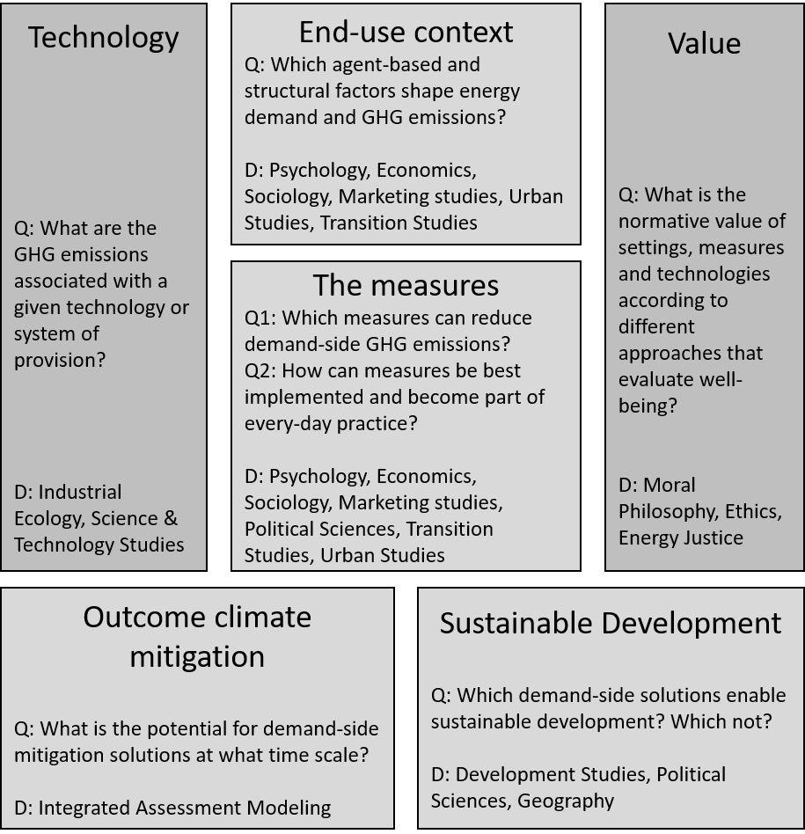

Figure . Key research questions and disciplinary contributions for assessing demand-side solutions that mitigate climate change. Q: Assessment question. D: Disciplines involved.

**The action – Identifying policy instruments**

Central questions arise on which measures can contribute to incremental, and transformative, demand-side solutions for mitigating climate change. Climate economists argue for pricing carbon as key policy instrument that is technology neutral and achieves mitigation efficiently. But while carbon pricing is a key instrument, issues like the path dependency of urban infrastructures, or imperfectly ‘rational’ agents point to the role of other or additional instruments that are relevant for end-users and consumers, and hence the importance of demand side mitigation. Political economy considerations also suggest that demand-side policies play an important role in policy sequencing8. In fact, human being as end users often have additional motives beyond the ‘perfect rationality’ of an economic agent, insights that have led to huge advances in behavioral psychology and behavioral economics9,10. As a result, ‘nudges’, subtle changes in choice architectures, have been proposed and implemented as suitable policy instrument11, without disqualifying the relevance of traditional regulatory policies12. Moreover, beyond individual choices, the social setting, every-day-practices of social groups, and physical infrastructures, such as street networks, have a direct and measurable impact on consumer choices and end-use demand4,13. In congested cities, company-level incentives, e.g. for telecommuting or bike riding, might be more relevant than monetary signals. Also, transport-oriented development enables low-carbon mobility and accessibility, enabling habit formation congruent with climate mitigation. These measures are particularly appealing in addressing multiple objectives14, and take center stage when focusing on well-being. While there are different emphases on solutions, the encompassing question is the same: Which policy instrument or measure can contribute how much for demand-side mitigation of climate change under what conditions and without reducing human well-being?

This question is useful but alone insufficient. In fact, there is a long history of useful policy proposals that never have been implemented due to the real constraints of policy makers on the ground: political economy; institutional functioning; and capacity constraints. Also, heterogeneity among people and social dynamics indicate the need for dynamic planning in policy design. This requires examining not only energy service provisions, but also service provision chains, which highlight how individual and systemic elements combine. Hence, an accompanying key question is: How can measures be best implemented and become part of local every-day-practices? Here, valuable insights can be derived from transition theory and the social sciences15.

To enable transdisciplinary discussions it is important to utilize common frameworks serving as focal points for discussions and research. As an example, we suggest the Avoid-Shift-Improve framework, well established in the Sustainable Transport community (Box 2), as an organization tool for driving demand-side policy measures for climate change mitigation. We argue that the Avoid-Shift-Improve categorization is intuitive to understand, helpful to identify measures that reduce GHG emissions, and applicable to all services and end-use sectors. As an illustration, we list a number of key avoid, shift, and improve measures for different end-use sectors and services (Table 1).

|  |
| --- |
| **Box 2. The Avoid-Shift-Improve framework.** The ASI approach originated in the early 1990s in Germany aiming to structure policy measures that reduce the environmental impact of transport, was then taken up by international NGOs to address rapid motorization in developing countries in the 2000s, and was endorsed by Asian and Latin American countries in the 2013 Bogota Declaration on Sustainable Transport16,17. According to the A-S-I approach, policies to limit GHG emissions in the transport sector need to consist of measures aimed at: (a) avoiding the need to travel, e.g. by improved urban planning, or teleworking, (b) shifting travel to the lowest carbon mode, e.g. cycling; and (c) improving vehicles by making them more energy efﬁcient and fuels less carbon intensive. The ASI approach organizes a large range of diverse policies, regulatory instruments and best practices. |

Table 1. Avoid-Shift-Improve options in different sectors and services. Many options, such as urban form and infrastructures are more systematic and influence several sectors simultaneously.

|  |  |  |  |  |
| --- | --- | --- | --- | --- |
|  | **Service** | **Avoid** | **Shift** | **Improve** |
| **Transport** | * Accessibility * Mobility | * Integrate transport & land use planning * Smart logistics * Tele-working * Compact cities | * Mode shift from car to cycling, walking, or public transit | * Electric two, three, and four wheelers * Eco-driving * Electric vehicles (various kinds) * Smaller, light-weight vehicles |
| **Buildings** | * Shelter | * Passive house or retrofit (avoiding demand for heating/ cooling) | * Heat pumps, district heating, combined heat and power | * Condensing boilers * incremental insulation options * Energy efficient appliances |
| **Industry** | * Clothing * Appliances | * Long lasting fabric, appliances, sharing economy, * eco-industrial parks, circular economy | * Virgin material to recycled materials, new materials for buildings and infrastructure | * Use of low carbon fabrics * New manufacturing processes and equipment use |
| **Food** | * Nutrition | * Calories in line with daily needs * Resource-efficient food production * Food waste reduction | * Healthy eating with choice of proportion of meat and dairy to plant protein | * Reuse food waste * Smaller, efficient fridges * Healthy fresh food to replace processed food |

**Technology – Accounting for GHG emissions, cost and potentials, and associated risks**

Policy options require an understanding of technologies for accurate evaluation. At the center is the assessment of direct and indirect GHG emissions associated with a specific behavior, technological choice, or infrastructure setting. Equally important are economic costs, and the potentials for scaling-up a given technological pathway. Industrial Ecology as a discipline becomes valuable here, due to its focus on system boundaries and life-cycle emissions, and therefore the calculation of policy impacts at the margin.

Beyond specific technologies, we also see scope for studies that take a wider scope and ask for the efficient, accessible and reliable provision of end-use services, rather than only efficient technology design (see also Box 1). For example, an abstract service, such as accessibility, can be systematically tested along a) physical requirement (is a physical trip required or can it be substituted, e.g. with telework); b) consumer preference (mode choice, e.g. car versus bike); c) use efficiency (e.g. the ratio of useful passenger weight to overall vehicle weight); d) service efficiency (e.g. car sharing versus private car); e) end-use efficiency (e.g. efficient fuel use of vehicle); and f) upstream efficiency (e.g. efficiency of fuel provision). Such a service-oriented perspective on emission reduction corresponds to the avoid-shift-improve approach: a) is avoid; b)-d) are shift; and e)+f) are improve options.

Technological studies, however, also contribute to a dynamic system understanding, outlining the path from research and development to market-scale deployment and uptake. Such insights are crucial not only for evaluating the potential of options, but also to clarify the timescales involved until technologies make a difference for climate mitigation. Insights on environmental or social risks associated with specific mitigation options are equally important to set the social boundaries for mitigation pathways.

**Morality – Well-being implications**

Energy demand-side actions interfere directly with the preferences, habits, and routines of people. Energy supply-side substitution, by contrast, has a less direct effect on peoples’ daily life, (though this is changing, as intermittent energy sources require demand-side adaptation). As a result, normative questions loom large in the evaluation of demand-side options for climate change mitigation, while questions of well-being often are put aside when energy supply is substituted. For example, consider that policy measures can change preferences. We hence must understand the assumption of exogenous preference as a special and not very plausible case18. Going beyond behavioral economics, humans should be modelled as enculturated agents19. Understanding how to optimally adjust policy to the presence of endogenous preferences and how policies can change these preferences are crucial matters for the accurate design of climate policy4.

Moral philosophy and welfare economics distinguishes three concepts of well-being: 1) preferences, a utility-based concept that has been the workhorse of micro-economics for the last seven decades; 2) hedonic concepts, such as those focusing on happiness and subjective well-being; and 3) eudaimonic approaches that encompass human needs and capability assessments20–22. Importantly, these different concepts may lead to sometimes similar but mostly diverging policy conclusions, as analyzed for the case of transportation23. Importantly, a focus on human needs can be translated into providing services (e.g., providing electricity for light and cooking). Therefore a focus on services rather than products enables the identification of wider mitigation options, but also enables the direct evaluation of well-being impacts and outcomes. A human needs approach also relates to some of the Sustainable Development Goals (see below).

The overarching question for normative evaluation is however more general: What is the normative value of settings, technologies and measures according to different approaches that evaluate well-being?

**Climate mitigation pathways**

Estimating the overall potentials for climate change mitigation is crucial. IAMs and, in more limited contexts, partial equilibrium models, are useful for assessing system-wide potentials, reflecting the interaction between sectors, and mitigation options. Most IAMs have a detailed description of supply-side technologies, but lack resolution on demand-side and, closely associated, with local solutions. However, IAMs and related models can summarize the insights from demand-side analysis, informed by bottom-up assessments of specific policy measures (see Technology section), and evaluate the comprehensive potential of demand-side mitigation options in their interaction with other options, such as supply-side technologies and energy-system decarbonization strategies. Such modeling studies must be informed by bottom-up assessments of specific policy measures (see Technology section). Modeling and other assessment studies can also clarify the time-scales over which actions and mitigations play out – an increasingly urgent requirement as time runs to reduce atmospheric CO2 concentration below levels consistent with less than 2°C warming.

**Sustainable Development**

We emphasized the importance of normatively evaluating the well-being implications of demand-side climate action. This also relates closely to sustainable development and the sustainable development goals (SDGs), which go beyond climate action (SDG 13) alone. For example, providing low-or-zero-carbon and resource efficient services equates with responsible consumption and production (SDG 12). But other SDGs are also directly implicated. Providing safe and sufficient nutrition tackles the zero hunger goal (SDG 2) and good health and well-being (SDG 3), electricity services for light, cooking and others are key for the affordable and clean energy goal (SDG 7), and providing mobility and accessibility services is closely related to achieving sustainable cities and communities (SDG 11). The linkage between sustainable development and climate change is also articulated in the “nationally determined” language of the Paris Agreement, with promotes climate mitigation that coincides with national determined development outcomes. A final key question emerges: Which demand-side solutions enable sustainable development? Which not?

Our list of key research questions may be incomplete, and others are likely to emphasize different angles. Nonetheless, we see an urgency for trans- and interdisciplinary synthetic research clarifying the demand-side solution space. We also see this area as intellectually exciting and stimulating with potential to transcend the specific issue of climate change mitigation, and providing broad research directions for a cohesive rather than fragmented social sciences.

The ambition of AR6 to fill crucial evidence gaps on the demand side is critical, as the IPCC assessments of available solutions have suffered from this neglect. We have outlined some key avenues for research that scientists need to tackle over the coming years. We call for collaborative and transdisciplinary efforts by relevant communities to achieve this fundamental goal.

**References**

1. Roy, J. & Pal, S. Lifestyles and climate change: link awaiting activation. *Curr. Opin. Environ. Sustain.* **1,** 192–200 (2009).

2. Wilson, C., Grubler, A., Gallagher, K. S. & Nemet, G. F. Marginalization of end-use technologies in energy innovation for climate protection. *Nat. Clim. Change* **2,** 780–788 (2012).

3. Stern, P. C., Sovacool, B. K. & Dietz, T. Towards a science of climate and energy choices. *Nat. Clim. Change* **6,** 547–555 (2016).

4. Creutzig, F. *et al.* Beyond Technology: Demand-Side Solutions for Climate Change Mitigation. *Annu. Rev. Environ. Resour.* **41,** 173–198 (2016).

5. Roy, J., Dowd, A.-M., Muller, A., Pal, S. & Prata, N. Lifestyles, well-being and energy. in *Global Energy Assessment (GEA)* 1527–1548 (Cambridge University Press, 2012).

6. von Stechow, C. *et al.* 2° C and SDGs: united they stand, divided they fall? *Environ. Res. Lett.* **11,** 034022 (2016).

7. Minx, J., Callaghan, M. W., Lamb, W. F., Kowarsch, M. & Edenhofer, O. Learning about climate change solutions. *Environ. Sci. Policy* (submitted).

8. Meckling, J., Sterner, T. & Wagner, G. Policy sequencing toward decarbonization. *Nat. Energy* 1 (2017). doi:10.1038/s41560-017-0025-8

9. Tversky, A. & Kahneman, D. The framing of decisions and the psychology of choice. *Science* **211,** 453–458 (1981).

10. Thaler, R. Toward a positive theory of consumer choice. *J. Econ. Behav. Organ.* **1,** 39–60 (1980).

11. Ebeling, F. & Lotz, S. Domestic uptake of green energy promoted by opt-out tariffs. *Nat. Clim. Change* **5,** 868–871 (2015).

12. d’Adda, G., Capraro, V. & Tavoni, M. Push, don’t nudge: Behavioral spillovers and policy instruments. *Econ. Lett.* **154,** 92–95 (2017).

13. Shove, E. Beyond the ABC: climate change policy and theories of social change. *Environ. Plan. A* **42,** 1273–1285 (2010).

14. Creutzig, F. & He, D. Climate Change Mitigation and Co-Benefits of Feasible Transport Demand Policies in Beijing. *Transp. Res. D* **14,** 120–131 (2009).

15. Geels, F. W., McMeekin, A., Mylan, J. & Southerton, D. A critical appraisal of Sustainable Consumption and Production research: The reformist, revolutionary and reconfiguration positions. *Glob. Environ. Change* **34,** 1–12 (2015).

16. Dalkmann, H. & Brannigan, C. Transport and Climate Change. Module 5e. Sustainable Transport: A Sourcebook for Policy-makers in Developing Cities. *Dtsch. Ges. Fuer Tech. Zusammenarbeit GTZ* (2007).

17. Bakker, S., Zuidgeest, M., De Coninck, H. & Huizenga, C. Transport, development and climate change mitigation: Towards an integrated approach. *Transp. Rev.* **34,** 335–355 (2014).

18. Bowles, S. Endogenous preferences: The cultural consequences of markets and other economic institutions. *J. Econ. Lit.* **36,** 75–111 (1998).

19. Hoff, K. & Stiglitz, J. E. Striving for balance in economics: Towards a theory of the social determination of behavior. *J. Econ. Behav. Organ.* **126,** 25–57 (2016).

20. Fleurbaey, M. & Blanchet, D. *Beyond GDP: Measuring welfare and assessing sustainability*. (Oxford University Press, 2013).

21. Brand-Correa, L. I. & Steinberger, J. K. A Framework for Decoupling Human Need Satisfaction From Energy Use. *Ecol. Econ.* **141,** 43–52 (2017).

22. Lamb, W. F. & Steinberger, J. K. Human well-being and climate change mitigation. *Wiley Interdiscip. Rev. Clim. Change* **8,** (2017).

23. Mattauch, L., Ridgway, M. & Creutzig, F. Happy or liberal? Making sense of behavior in transport policy design. *Transp. Res. Part Transp. Environ. Forthcom.* (2015).